How to Do Things with Words II: Critical Discourse Analysis
HANDOUT

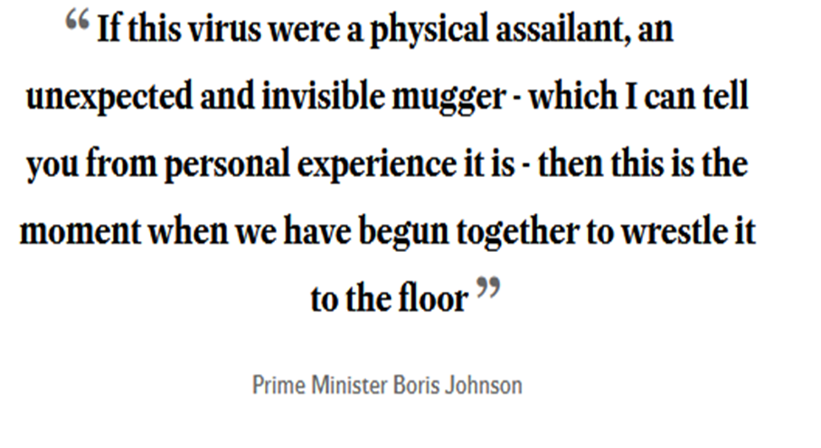

Covid in the Headlines
Boris says NO new Covid curbs and the country can 'ride out' the Omicron wave as he puts NHS on a 'war footing' - after daily infections hit a new high of 218,000
Boris Johnson said Plan B curbs should stay in place as country 'rides out' the wave of Omicron infections [Mail Online]
Boris Johnson wants to ‘ride out’ the Omicron Covid wave while NHS staff like me know lives are at risk https://inews.co.uk/opinion/boris-johnson-omicron-covid-wave-nhs-staff-lives-risk-1382601
Boris Johnson faces scrutiny over plan to ‘ride out’ Omicron without fresh rules. The Prime Minister will argue to his Cabinet on Wednesday they should stick by the Plan B measures in England as he accepted parts of the health service will feel “temporarily overwhelmed”.
Boris Johnson suggests country can 'ride out' Omicron Covid wave without further restrictions. Boris Johnson has appeared to rule out any further coronavirus measures in England for now, as he said that Plan B restrictions are seemingly sufficient to “ride out” the Omicron wave. [Yorkshire Post, 4 Jan 2022 ‘News you can trust’)
Boris Johnson sticks with plan B in bid to 'ride out' Omicron without lockdown. Boris Johnson has said there is a "good chance" he will not impose fresh restrictions to tackle the massive wave of Omicron cases, as he backed sticking with Plan B measures despite acknowledging parts of the NHS will feel "temporarily overwhelmed". (Scotsman, 4 Jan 2022)
Parts of NHS may be overwhelmed by Covid wave, admits Boris Johnson. PM says England can ‘ride out’ Omicron without lockdown but acknowledges service is under huge pressure (Guardian, 4 Jan 2022)

